COUNTY OF ALBEMARLE
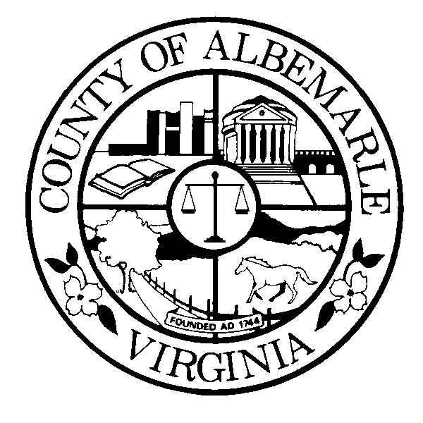

OFFICE OF FACILITIES DEVELOPMENT

MEMORANDUM

TO: Members of the Board of Supervisors
Members of the Albemarle County School Board

FROM: Bill Letteri, Director

DATE: December 9, 2010

SUBJECT: Joint Board Meeting on CIP

This memo is to provide summary remarks and background information regarding this year’s Capital Improvements Program review process in advance of your joint discussion on Wednesday, December 15, 2010.

The Technical Review Team (TRT) and the CIP Oversight Committee (OSC) conducted several meetings to prepare a proposed CIP for the County Executive’s consideration. As you may recall, this was an “Amendment Year”, meaning only critical projects, or those impacting health or safety, are considered.

The Committees were again challenged this year to develop a balanced plan that addresses the County’s most critical needs within limited resources. In advancing the proposed plan, the OSC acknowledges that there are, as yet, unfunded capital and infrastructure needs; however, the plan does achieve the following:

- Provides adequate funds to properly maintain our existing facilities;
- Provides necessary funding to support technology systems, special equipment replacements and apparatus replacements over the next five years;
- Includes plan for funding Ivy Fire Station and Greer Phase II;
- Results in targeted reserve balances at the end of the CIP period.

Attached for your review are the following documents:
- FY12-16 CIP Proposed Project Summary
- FY12-16 CIP Financial Summary
- Ivy Fire Station - CIP Fund Reallocation Considerations
- Proposed Statement Regarding Apparatus Replacement Policy

I will review this information in detail at our meeting on Wednesday, including a discussion of revenue assumptions, request adjustments, unfunded projects and recommendations regarding apparatus replacement policies and maintenance funding.

BL/ps

